TradeOps
A Data Warehouse for Prop-Firm Futures Trading Operations
Group Number | Group 08
Participant | Jesus D. Jimenez Ballestas
Project Title | TradeOps: A Data Warehouse for Prop-Firm Futures Trading Operations
Data Source | Generated through a seeded Python script (synthetic), using real contract specifications

1. Project Summary
This project focuses on building a data warehouse for a futures trading operation that uses capital provided by proprietary trading firms, or "prop firms," instead of trading only with personal funds. The operation manages dozens of evaluation and funded accounts across several firms, while a single trade can be copied to every active account at the same time. Because each firm has different rules, fees, and payout schedules, the information needed to evaluate overall performance is spread across multiple dashboards and platform exports. The main goal of the project is to bring this information together in one place so it becomes easier to answer an important question: after all fees are included, is the operation actually profitable, and which strategies, instruments, and firms contribute the most to the results?

2. Operational Business Context
A prop firm gives traders access to an evaluation account for a fee. For example, a trader might pay a monthly fee for a $50,000 evaluation account. To pass the evaluation, the trader must reach a profit target while keeping the account balance above a trailing drawdown limit that moves with the account's highest balance. Some firms also have daily loss limits and consistency rules that restrict how much of the total profit can come from one trading day. After passing the evaluation, the trader receives a funded account, usually after paying an activation fee. The trader can then request payouts and typically keeps most of the profit, commonly around 90%. If the account balance reaches the drawdown limit, the account is lost.
This project looks at that process on a larger scale. The operational database needs to support the following day-to-day activities:
- Account management: purchasing evaluation accounts, paying monthly and reset fees, and activating funded accounts after an evaluation is passed.
- Trade execution: a trade is placed in a leader account, and copy-trading software sends the same trade to each follower account, although position sizes and fills can differ.
- End-of-day statements: each firm reports information such as the account's ending balance, high-water mark, and drawdown floor.
- Rule monitoring: tracking events such as drawdown breaches, daily loss-limit violations, and consistency-rule flags.
- Payouts: recording withdrawal requests from funded accounts based on each firm's payout schedule.
These are transactional processes because they usually add or update a small number of records at a time and mainly depend on current data. This matches the OLTP workload described in Section 3.1 of Vaisman and Zimányi (2022). The type of analysis needed for this project is different because it requires combining and summarizing historical information, which supports the need for a separate data warehouse.

3. Problem Definition
Problem statement. The operation does not currently have an easy way to measure its true return because expenses, such as evaluation, reset, and activation fees, are stored separately from trading results and payout income. Each prop firm also reports its information in a different format. As a result, it is difficult to determine which strategies, trading sessions, or instruments are connected to the drawdown violations that cause accounts to fail. It is also difficult to compare copied trades with the original leader trade. This project will first create an operational database that records these events and will later use a data warehouse to combine the information for multidimensional analysis.
The project is designed to answer the following business questions:
- What is the operation's net return, calculated as payouts received minus all fees, by firm, plan, and month?
- Which strategies and instruments generate the most net P&L, and which ones are associated with the most rule violations?
- How does trading performance differ by session and on major economic event days such as CPI, NFP, and FOMC?
- What percentage of evaluations are passed, how long does it take to pass them, and how long do funded accounts remain active?
- How much additional slippage is created when trades are copied from the leader account?
Scope. The project includes futures trades, account lifecycles, fees, balances, rule violations, and payouts from January 2025 through August 2026. Live market data, order-book data, and personal tax reporting are outside the scope of the project.

4. Operational Database
The TradeOps operational database contains 16 tables organized in Third Normal Form (3NF). The DDL uses PostgreSQL syntax and was loaded and tested in DuckDB. Primary keys, foreign keys, and CHECK constraints were enforced during testing. Figure 1 shows the current relationships between the tables and will serve as the starting point for the full ERD developed in later milestones.
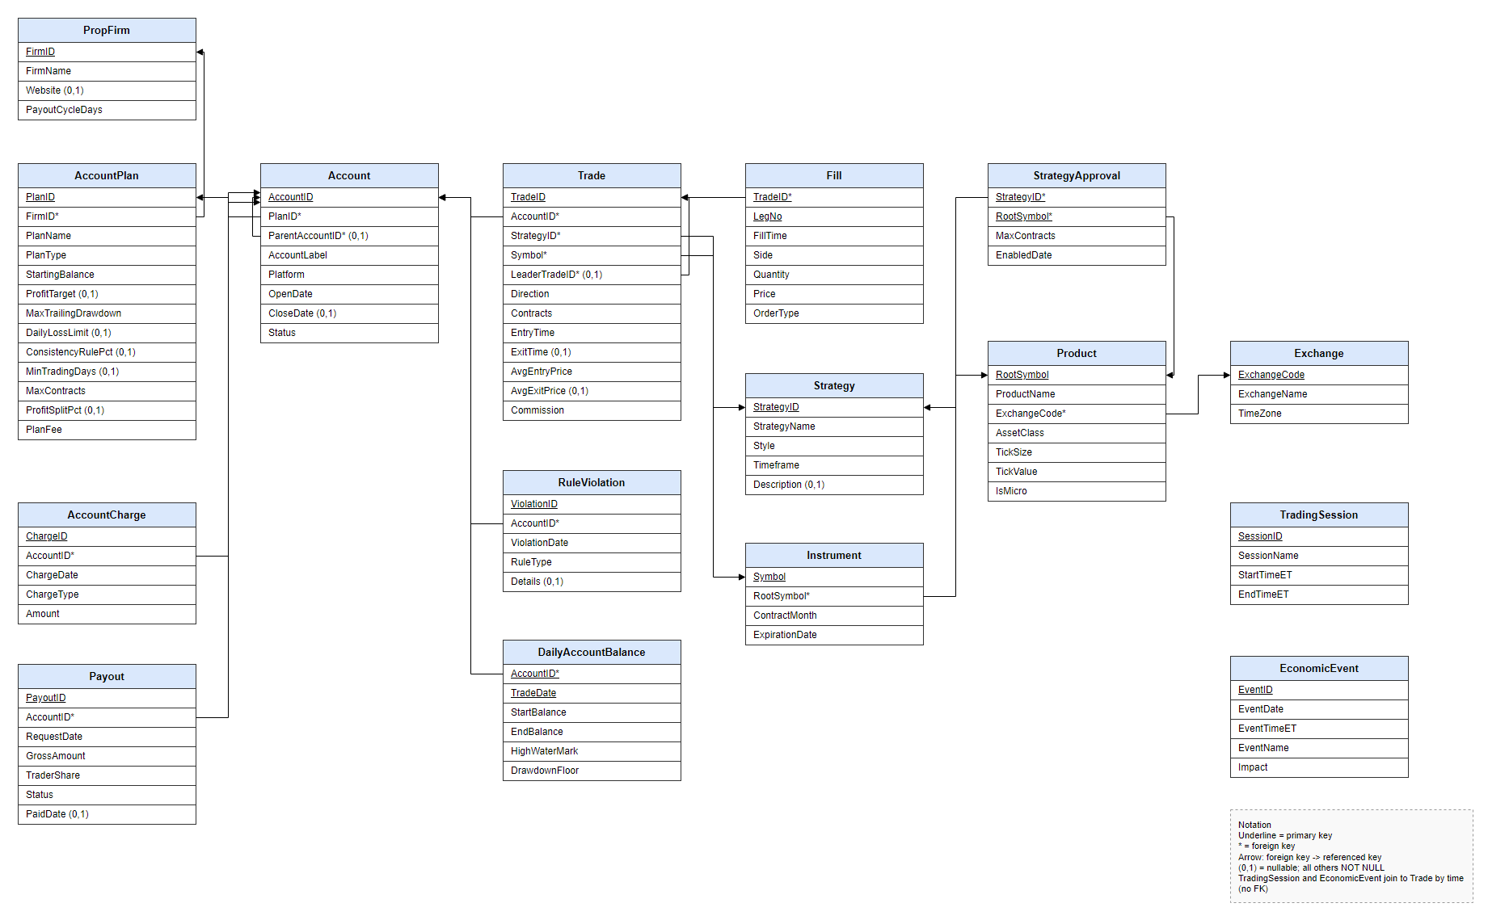
F1. TradeOps

4.1 Static Reference Data
Reference data does not change very often and describes the basic "who, what, and where" behind each transaction. Most of these tables are expected to become dimensions in the future data warehouse.
Table | Contents | Rows
PropFirm | The three prop firms included in the operation and their payout cycles | 3
AccountPlan | Plans offered by each firm, including starting balance, profit target, trailing drawdown, daily loss limit, consistency %, profit split, and fee | 8
Exchange | The exchanges used in the dataset: CME, CBOT, NYMEX, and COMEX | 4
Product | 12 futures products (for example, NQ, MNQ, ES, CL, and GC) with their actual tick size and tick value | 12
Instrument | Specific contract months (for example, NQZ5) and their expiration dates | 164
Strategy | Five trading strategies, including each strategy's style and timeframe | 5
StrategyApproval | Identifies which products each strategy is allowed to trade and the contract limit (M:N) | 24
TradingSession | Time windows in ET for Asia, London, NY Open, NY Midday, and NY Close | 5
EconomicEvent | Rule-based calendar containing CPI, NFP, FOMC, retail sales, jobless claims, and EIA releases | 245
T1. Reference tables

4.2 Transactional Data
Transactional data captures business events as they occur. These tables will later provide the source data for the warehouse fact tables.
Table | Contents | Rows
Account | All evaluation and funded accounts, including plan, status, and the evaluation that produced each funded account | 134
AccountCharge | Evaluation, monthly, reset, and activation charges | 220
Trade | Round-trip trades with entry and exit times and prices, contracts, commissions, and the related leader trade | 6,322
Fill | Individual trade executions, including partial exits and scale-outs | 13,944
DailyAccountBalance | End-of-day account information, including starting balance, ending balance, high-water mark, and drawdown floor | 2,916
RuleViolation | Drawdown breaches, daily loss-limit violations, and consistency flags | 143
Payout | Payout requests, including gross amount, trader share, and request status | 63
T2. Transactional tables

4.3 Data Source and Design Notes
The dataset is created with a seeded Python script, which means the same data can be reproduced whenever the script is run with the same seed. The design is based on a real trading operation I run, but the records themselves are synthetic and do not include my actual trades. Product details such as tick size and tick value follow real CME Group contract specifications, and the economic-event calendar follows common release schedules, such as NFP being released on the first Friday of the month. The prop-firm names are real, but the plan rules and fees are simplified and stored as reference data so they can be updated without changing the code. Across the 20-month simulated period, the dataset contains 102 evaluations, with 32 passing, 32 funded accounts, $17,497.60 in fees, and $58,950 in payouts paid to the trader.
Several design decisions will also be important in later milestones:
- Rules are stored in AccountPlan instead of Account. Profit targets and drawdown limits are based on the plan, so repeating those values in every account record would create a transitive dependency and violate 3NF.
- The database uses two self-referencing foreign keys. Account.ParentAccountID connects a funded account to the evaluation that produced it. Trade.LeaderTradeID connects each copied trade to its original leader trade. The simulated data contains 1,014 leader trades and 5,308 copied trades.
- Fill is modeled as a weak entity with the composite key (TradeID, LegNo), allowing one trade to contain multiple execution or exit legs.
- P&L is not stored directly in the operational database. Instead, it can be calculated from trade prices, contract quantities, and tick value. This avoids storing redundant data in the OLTP system, and the ETL process will calculate P&L when the data is moved into the warehouse.

5. Planned Analysis (Future Milestones)
The analysis ideas below may be adjusted as the course progresses, but they show how the operational data can later be organized into a multidimensional warehouse model.

5.1 Candidate Facts and Dimensions
Fact (grain) | Measures | Dimensions
Trade (one row per trade) | Net P&L, gross P&L, contracts, commission, slippage vs. leader, hold minutes | Date, Time/Session, Account, Plan, Firm, Instrument, Product, Strategy, Event day
Daily account snapshot (one row per account per day) | End balance, cushion to drawdown floor, high-water mark | Date, Account, Plan, Firm
Account cash flow (one row per charge or payout) | Fee amount, payout amount, trader share | Date, Account, Plan, Firm, Flow type
T3. Candidate fact tables
The dimensions also support natural roll-up and drill-down hierarchies. These include Day -> Month -> Quarter -> Year, Time -> Session, Instrument -> Product -> Asset Class, Account -> Plan -> Firm, and Strategy -> Style.

5.2 Measure Additivity
As discussed in Section 3.1.2, not every measure should be aggregated in the same way. Choosing the correct aggregation method is important for keeping warehouse summaries accurate:
- Additive: net P&L, contracts, commissions, fees, and payouts can be added across all dimensions.
- Semi-additive: end balance and drawdown cushion can be added across different accounts for the same day, but across time it makes more sense to use the latest value or an average.
- Non-additive: win rate, profit factor, and pass rate are ratios and should not simply be added together. The warehouse will keep the underlying counts and totals needed to calculate these ratios when a query is run.

5.3 Analysis Directions
- Return on fees: summarize payouts and charges by Firm and Month, then compare them with trading P&L to understand the net return produced by each firm.
- Strategy and session performance: filter the trade cube by Strategy and Session to compare where each strategy performs well or poorly.
- Risk and early warning: examine daily account snapshots for accounts that eventually breached a rule to see how their drawdown cushion changed before the breach occurred.
- Event-day effects: compare P&L and rule violations on CPI, NFP, and FOMC days with results from regular trading days.
- Copy-trading quality: compare copied trades with their leader trades to measure slippage by prop firm and trading platform.
- Account lifecycle: analyze evaluation pass rates, the number of days required to pass, and how long funded accounts remain active.

5.4 Considerations for Later Milestones
- ETL: trade and fill records can be loaded incrementally using entry time, while P&L can be calculated during the transformation step.
- Slowly changing dimensions: prop firms can change plan rules and fees over time, so the Plan dimension is a strong candidate for a Type 2 slowly changing dimension to preserve historical versions.
- Integration: in a real system, each prop firm may export its data in a different format. Bringing those sources together reflects the "integrated" characteristic of a data warehouse described in Section 3.3.

References
Vaisman, A., & Zimányi, E. (2022). Data warehouse systems: Design and implementation (2nd ed.). Springer.

